**Limits and Continuity**

Table of Contents

Neighbourhoods in a Plane 2

Limit of a Function of Two Variables 4

Continuity of a Function of Two Variables 6

Continuity of a Function of Three Variables 7

## Neighbourhoods in a Plane

We can define the $δ$**-neighbourhood** about $\left(x_{0}, y_{0}\right)$ as a disk with radius $δ>0$, with $\left(x, y\right)$ being points on the circumference of the disk.

$$\sqrt{{\left(x-x_{0}\right)}^{2}+{\left(y-y_{0}\right)}^{2}}<δ$$



If we use the $<$ sign, the disk is said to be **open** and if we use the $≤$ sign, the disk is said to be **closed**.



Let $R$ be a region in a plane. A point $(x_{0}, y_{0}$) is said to be an **interior point** of $R$ if the $δ$-neighbourhood of the point lies entirely inside $R$. If every point in $R$ is an interior point, then $R$ is said to be an **open region**.

A point $\left(x_{0}, y_{0}\right)$ is said to be a **boundary point** of $R$ if every open disk centred at that point has points inside $R$ and outside $R$. If $R$ contains all its boundary points, it is said to be a **closed region**.

## Limit of a Function of Two Variables

Let $f$ be a function of two variables, defined everywhere except possibly at $\left(x_{0}, y_{0}\right)$, on an **open disk** centred at $\left(x_{0}, y_{0}\right)$ and let $L$ be a real number. Then,

$$\lim_{\left(x, y\right)→\left(x_{0}, y_{0}\right)}{f\left(x, y\right)=L}$$

if, for each $ϵ>0$, there corresponds a $δ>0$ such that

$\left|f\left(x, y\right)-L\right|<ϵ$ whenever $0<\sqrt{{\left(x-x\right)}^{2}+{\left(y-y_{0}\right)}^{2}}<δ$

Graphically, all this means is that for any point $\left(x, y\right)≠\left(x_{0}, y_{0}\right)$ in the disk of radius $δ$, the value of $f\left(x, y\right)$ will be **within $L+ϵ$ and $L-ϵ$** .

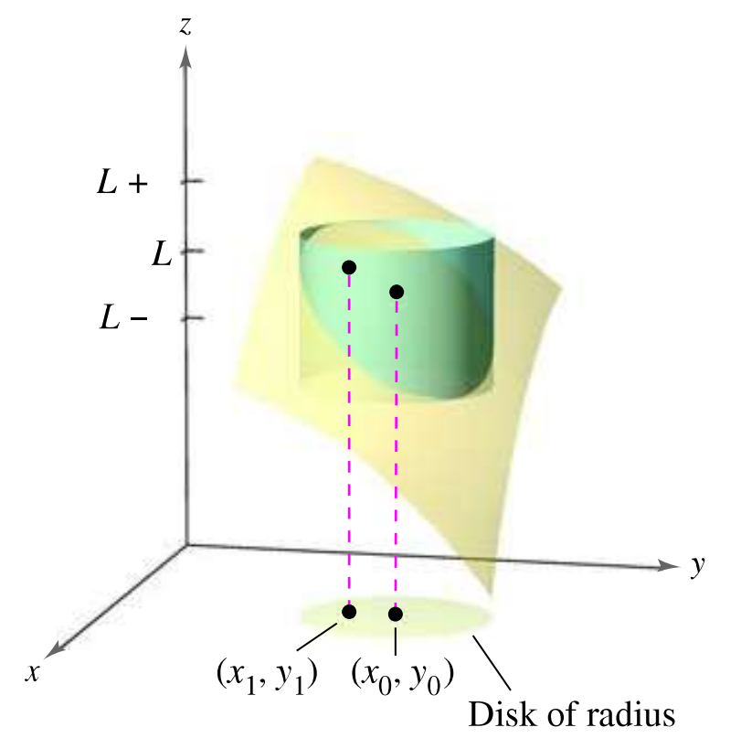

Verifying that a limit exists requires that we handle things like how we did with complex variables. We need to ensure that the limit is the same **regardless of the direction** from which we approach $\left(x_{0}, y_{0}\right)$.

Limits of a function of several variables exhibit the same properties for sums, differences, products and quotients that limits of functions of single variables do.

For some functions, it is easy to see that a **limit does not exist**. For example, for $\lim_{\left(x, y\right)→\left(0, 0\right)}{\frac{1}{x^{2}+y^{2}}}$, it is obvious that a limit does not exist because the value of $f\left(x, y\right)$ increases indefinitely as $\left(x, y\right)$ approaches $\left(0, 0\right)$ along **any path**.

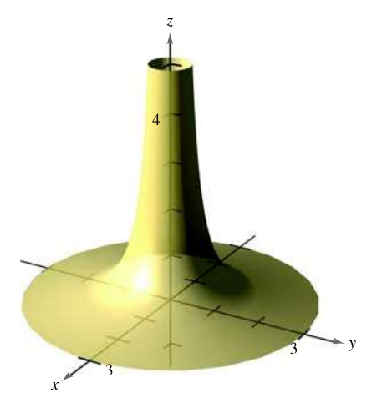

## Continuity of a Function of Two Variables

If the value of the limit of a function and the actual value of the function at that point are the same, the function is said to be **continuous** at the point.

$$\lim_{\left(x,y\right)→\left(x_{0}, y_{0}\right)}{f\left(x, y\right)}=f\left(x_{0}, y_{0}\right)$$

If $k$ is a real number and $f\left(x, y\right)$ and $g\left(x, y\right)$ are continuous at $\left(x_{0}, y_{0}\right)$, then the following functions are also continuous at that point:

$kf$

$f±g$

$fg$

1. $\frac{f}{g}$, given that $g\left(x_{0}, y_{0}\right)≠0$

If $h$ is continuous at $\left(x_{0}, y_{0}\right)$ and $g$ is continuous at $h\left(x_{0}, y_{0}\right)$, then $\left(g∘h\right)\left(x_{0}, y_{0}\right)$ is continuous at $\left(x_{0}, y_{0}\right)$.

## Continuity of a Function of Three Variables

$${\left(x-x_{0}\right)}^{2}+{\left(y-y_{0}\right)}^{2}+{\left(z-z_{0}\right)}^{2}<δ^{2}$$